SMART BLOOD DONOR AND REQUEST SYSTEM
21CSC205P Database Management Systems
A MINI PROJECT REPORT

Submitted by
AAYUSHA KUILEL [RA2411030122589]
SAMIR DHAKAL[RA2411003012590]

Under the Guidance of

(DR SANTHIYA PARIVALLAL)
(ASSISTANT PROFESSOR , Department of Computing Technologies )

in partial fulfillment of the requirements for the degree of

BACHELOR OF TECHNOLOGY

in

COMPUTER SCIENCE ENGINEERING


DEPARTMENT OF NETWROKING AND COMMUNICATIONS

SCHOOL OF COMPUTING

COLLEGE OF ENGINEERING AND TECHNOLOGY
SRM INSTITUTE OF SCIENCE AND TECHNOLOGY

KATTANKULATHUR- 603 203

February 2026


SRM INSTITUTE OF SCIENCE AND TECHNOLOGY KATTANKULATHUR – 603 203

BONAFIDE CERTIFICATE

Certified that Project report titled “Smart Blood Donor and Request System” is the bonafide work of “AAYUSHA KUIKEL [RA2411003012589], SAMIR DHAKAL[RA2411003012590]” who carried out the 21CSC205P Database Management Systems mini project work under my supervision.

COURSE FACULTY | HEAD OF THE DEPARMENT
ASSISTANT PROFESSOR  Department of Computing Technologies | PROFESSOR AND HEAD  Department of Computing Technologies

ABSTRACT
In critical medical situations such as accidents, surgeries, and emergencies, the timely availability of compatible blood can be a matter of life and death. However, existing blood donation systems often suffer from fragmented data, manual processes, and delayed communication, making it difficult to quickly identify suitable donors and available blood stock. This project aims to design and develop a Smart Blood Donor and Request System supported by a robust and well-structured database to address these challenges.
The core focus of the project is the design and implementation of an efficient database management system that acts as the backbone of the application. The system centrally manages donor information, blood bank details, blood stock availability, and blood requests, enabling fast retrieval and accurate matching of blood requirements with available resources. By using a structured relational database architecture, the system ensures data integrity, consistency, and scalability.
Key components of the project include:
- Donor Management: Secure storage and management of donor details such as blood group, contact information, and donation history.
- Blood Bank Management: Centralized management of blood bank information and real-time monitoring of blood stock levels.
- Blood Request Handling: Efficient recording and processing of blood requests based on urgency, quantity, and blood group requirements.
- Data Integrity and Analysis: Use of database constraints, relationships, and queries to ensure reliable data handling and support decision-making.
The project is designed following standard database design principles, including ER modeling, normalization, and relational schema implementation. By leveraging SQL and MySQL, the system provides a scalable, efficient, and reliable solution that enhances coordination between donors and blood banks. Ultimately, the Smart Blood Donor and Request System aims to improve response time, optimize blood resource utilization, and support healthcare services in saving lives through effective data-driven management.

TABLE OF CONTENTS

Chapter No. | Title | Page no.
 | ABSTRACT
1 | Problem understanding, Identification of Entity and Relationships, Construction of DB using ER Model for their project
2 | Design of Relational Schemas, Creation of Database and Tables for their project
3 | 3.1Writing queries based on the concepts of Aggregate functions, constraints, sets
 | 3.2 Writing complex queries based on subqueries, joins and views
 | 3.3 Writing complex queries based on the concepts of functions, Triggers, Cursors and Exception Handling
4 | 4.1 Analysing the pitfalls, identifying the dependencies, and applying Normalizations- 1NF, 2NF, 3NF
 | 4.2 Analysing the pitfalls, identifying the dependencies, and applying Normalizations- 4NF, 5NF
5 | Implementation of concurrency control and recovery mechanisms.
6 | Front-end And Back-End Implementation code
7 | Results and Discussions

LIST OF FIGURES

Figure No. | Name | Page no.
1
2
3
4
5

LIST OF TABLES

Figure No. | Name | Page no.
1
2
3
4
5

CHAPTER 1

PROBLEM UNDERSTANDING, IDENTIFICATION OF ENTITY AND RELATIONSHIPS, CONSTRUCTION OF DB USING ER MODEL FOR THE <PROJECT Name>

  - Introduction
  - Motivation
  - Scope
  - Problem Statement
  - Project Requirements
  - Identification of Entity and Relationships
  - Construction of DB Using ER Model for the <Project name>

Note:
- Use font family: Times new roman, size 12
- Figure name: Chapter no. Figure no: Figure Name, Place in in bottom center of the figure (eg: Figure 1.1: ER diagram of Student Management System)
- Figures must be clear with all text inside it visible
- Table name: Chapter no. Table no: Table name, Place in in top center of the table
(eg: Table 1.1: Student Schema)
- Table must not be pasted in image format, must be editable
- All text must be properly aligned (justified)
- Set the page margin
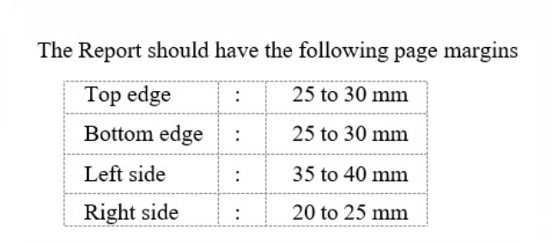
Chapter 2
Design of Relational Schemas, Creation of Database and Tables for <Project Title>

2.1 Relational Schema for <project title>
Sample
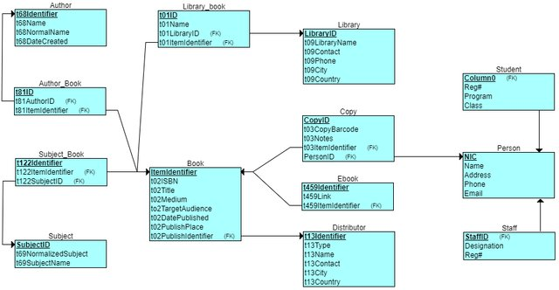
Figure 2.1: Relational Schema for <project title>
The figure 2.1 depicts the relational schema for the <project title> . (give explanation)

2.2 Description of Tables
Sample
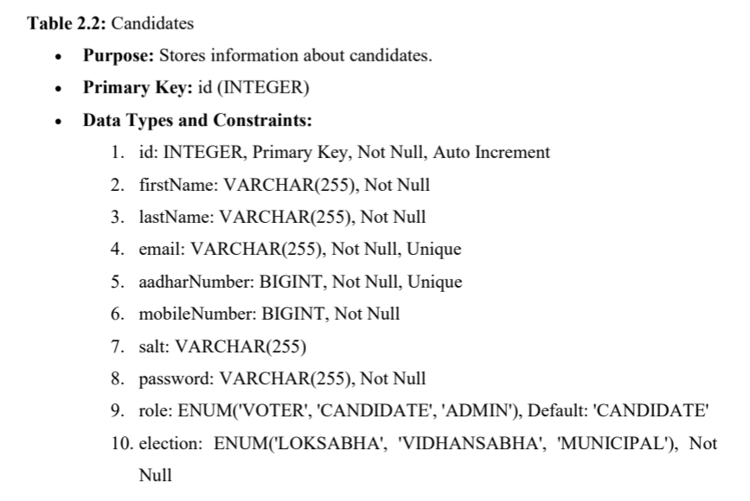

List all the table with the attributes, datatypes, size, constraints
2.3 Creation of Database and Tables - DDL Commands
DDL Commands to create all the tables
2.4 Insertion of tuples into the table – DML commands
Insert SQL (for all tables)
Example:
INSERT INTO Customers (CustomerName, ContactName, Address, City, PostalCode, Country) VALUES ('Cardinal', 'Tom B. Erichsen', 'Skagen 21', 'Stavanger', '4006', 'Norway'),
('Greasy Burger', 'Per Olsen', 'Gateveien 15', 'Sandnes', '4306', 'Norway'),
('Tasty Tee', 'Finn Egan', 'Streetroad 19B', 'Liverpool', 'L1 0AA', 'UK');
Customer table:
CustomerID | CustomerName | ContactName | Address | City | PostalCode | Country
89 | White Clover Markets | Karl Jablonski | 305 - 14th Ave. S. Suite 3B | Seattle | 98128 | USA
90 | Wilman Kala | Matti Karttunen | Keskuskatu 45 | Helsinki | 21240 | Finland

CHAPTER 3
Complex queries based on the concepts of constraints, sets, joins, views, Triggers and Cursors.
(min 3 questions with queries for all topics)
< create complex queries based on the sub-topic with questions and SQL statement with output>

  - Adding Constraints and queries based on constraints
Question:

SQL Statement:

Output:

  - Queries based on Aggregate Functions

Question:

SQL Statement:

Output:

  - Complex queries based on Sets
Question:

SQL Statement:

Output:

  - Complex queries based on Subqueries

Question:

SQL Statement:

Output:

  - Complex queries based on Joins
Question:

SQL Statement:

Output:

  - Complex queries based on views
Question:

SQL Statement:

Output:

  - Complex queries based on Triggers
Question:

SQL Statement:

Output:

  - Complex queries based on Cursors
Question:

SQL Statement:

Output:

CHAPTER 4

ANALYZING THE PITFALLS, IDENTIFYING THE DEPENDENCIES, AND APPLYING NORMALIZATIONS

(show the table before and after respective normalization)

4.1 Analyse the Pitfalls in Relations
4.2 First Normal Form
4.2.1: Identify Dependency
4.2.2: Apply Normalization to 1NF

4.3 Second Normal Form
4.3.1: Identify Dependency
4.3.2: Apply Normalization to 2NF

4.4 Third Normal Form
4.4.1: Identify Dependency
4.4.2: Apply Normalization to 3NF

4.5 BCNF
4.5.1: Identify Dependency
4.5.2: Apply Normalization to BCNF

4.6 Fourth Normal Form
4.6.1: Identify Dependency
4.6.2: Apply Normalization to 4NF

4.7 Fifth Normal Form
4.7.1: Identify Dependency
4.7.2: Apply Normalization to 5NF

CHAPTER 5
IMPLEMENTATION OF CONCURRENCY CONTROL AND RECOVERY MECHANISMS

5.1 Introduction to Transactions
5.1.1 Properties
5.1.2 States
5.2 Transaction Control Language (TCL)
5.2.1 Save point
5.2.2 Commit
5.2.3 Rollback

5.3 create 5 transactions for your project and execute
5.3.1 Transaction1 code with output (min 5 transactions)
Use savepoints, commit, rollback
< Sample:
-- Step 1: Start transaction by updating book availability
UPDATE Books
SET available_copies = available_copies – 1 WHERE book_id = 101;

-- Step 2: Set a savepoint after first change
SAVEPOINT after_first_update;

-- Step 3: Another update
UPDATE Books SET available_copies = available_copies – 1 WHERE book_id = 102;

-- Step 4: Oops! Something's wrong with second update, rollback to savepoint
ROLLBACK TO after_first_update;

-- Step 5: Continue with a safe update
UPDATE Books SET available_copies = available_copies + 1 WHERE book_id = 101;

-- Step 6: Commit all changes since savepoint
COMMIT; >

Sample 2:
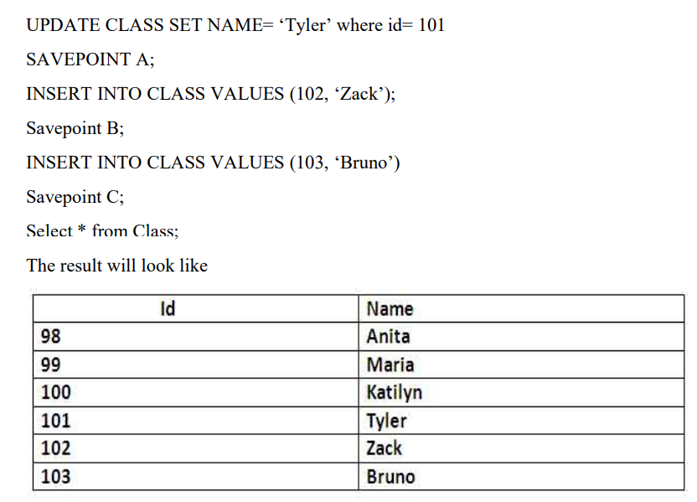
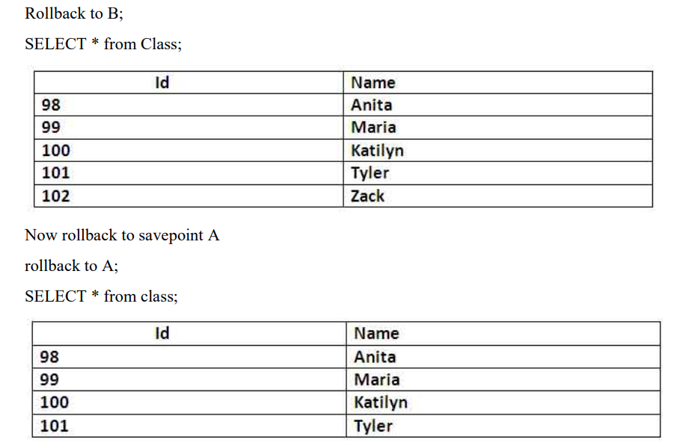

5.3 Concurrency control
5.3.1 Concurrency control Algorithms
5.3.1 Locking commands
a. Row-Level Locking – SELECT ... FOR UPDATE
b. Table-Level Locking – LOCK TABLE
Lock Modes
Lock Mode | Description
ROW SHARE | Allows concurrent access; prevents other sessions from locking the table exclusively.
ROW EXCLUSIVE | Prevents other sessions from locking in share mode. Used by default for DML.
SHARE | Allows queries but not updates or deletes.
SHARE ROW EXCLUSIVE | A mix; more restrictive than SHARE.
EXCLUSIVE | Prevents all other access — full table lock.

c. COMMIT – Release All Locks
d. ROLLBACK – Undo Changes & Release Locks
5.3.2 Example (1 example for your project)

CHAPTER 6
FRONT-END AND BACK-END CODE OF <PROJECT TITLE>

6.1 Front–End Module codes
6.2 Database connectivity

CHAPTER 7
RESULTS AND DISCUSSIONS

7.1 Screenshots of front-end

7.2 Screenshots of Database

References

